**DOMAIN: ARTIFICIAL INTELLIGENCE**

**PROJECT TITLE:EARTHQUAKE PREDICTION USING PYTHON**



TEAM MEMBERS

1 . SRINIDHI R [511321104096]

2 . SOUNDARYA S [511321104094]

3 . THRISHA V [511321104103]

4 . SANDHIIYA V [511321104087]

-kingston engineering college

In this code, we've done the following:

* Loaded the preprocessed dataset.
* Selected the features (**Latitude**, **Longitude**, and **Depth**) as **X** and the target variable (**Magnitude**) as **y**.
* Split the data into training and testing sets using **train_test_split**.
* Created a simple linear regression model, trained it using the training data, and made predictions on the test data.
* Evaluated the model's performance using metrics like Mean Squared Error (MSE) and R-squared (R2).
* Visualized the relationship between actual and predicted magnitudes.

CODE :

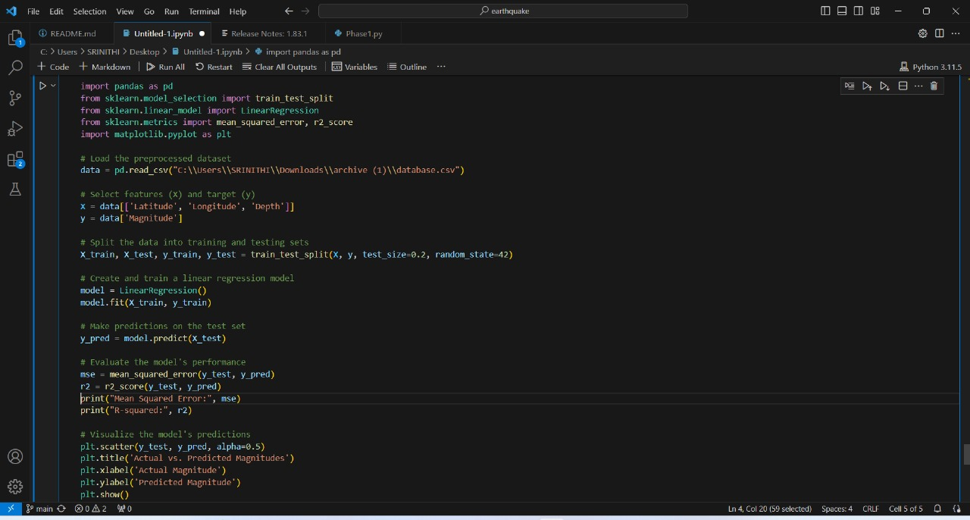

OUTPUT:

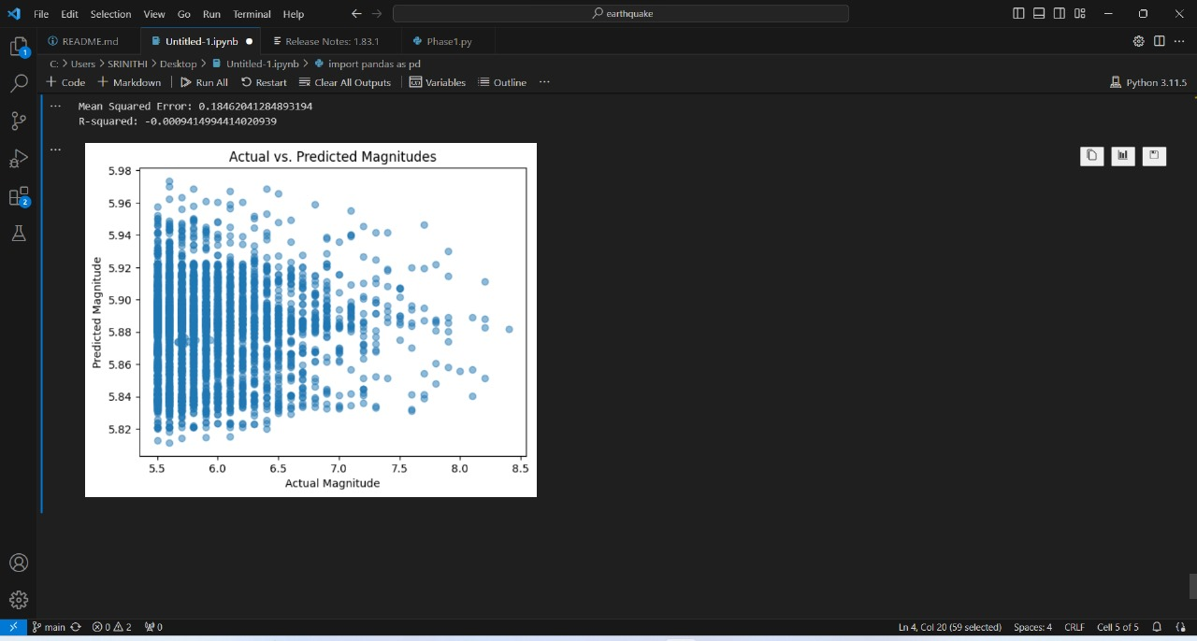

FOR VISUALISING THE DATA ON THE WORLD MAP

CODE:

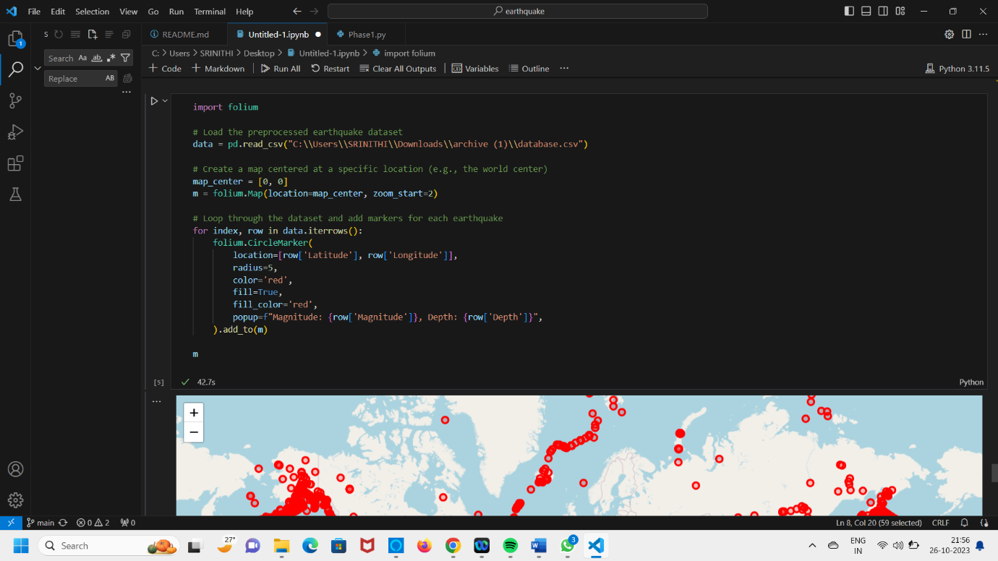

OUTPUT:

